Overview
The purpose of this guide sheet is to provide guidance on starting a new protocol, completing the form and submitting the protocol to the IACUC office for review.

Supported Browsers
Chrome, Safari, and Firefox

Initiating a New Protocol
- Before initiating a new protocol, make sure that the PI in the upper right-hand corner is correct. The name showing will be the PI on the IACUC protocol. If you are not part of another PI group, the system will only show your name.

- Click on +Start a New Protocol Application from the Protocol Actions alert tab.

- Options Page: the questions here will populate additional pages for the form once saved. Complete this page.
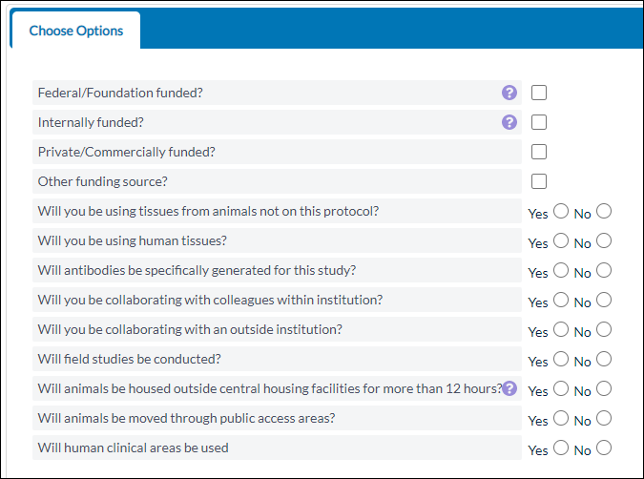

4. You will also need to update your Protocol Species Grid by clicking Add.
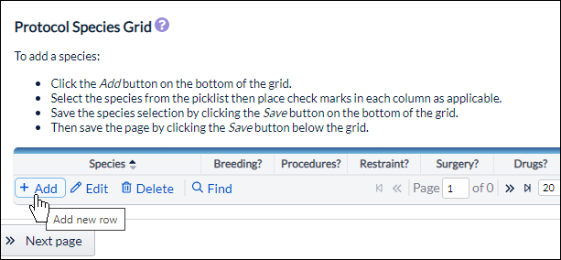
5. Select your species from the dropdown, select which procedures the animal will undergo, and click Save.
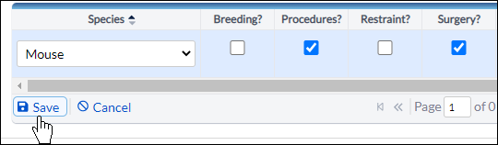

6. When you click Save, the selections made in the Options page determine which sections are added to the Table of Contents.
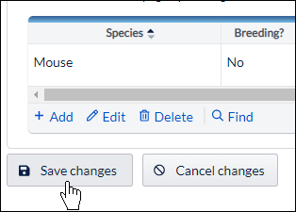

7. You can navigate to any section by clicking on the section name within the Table of Contents.
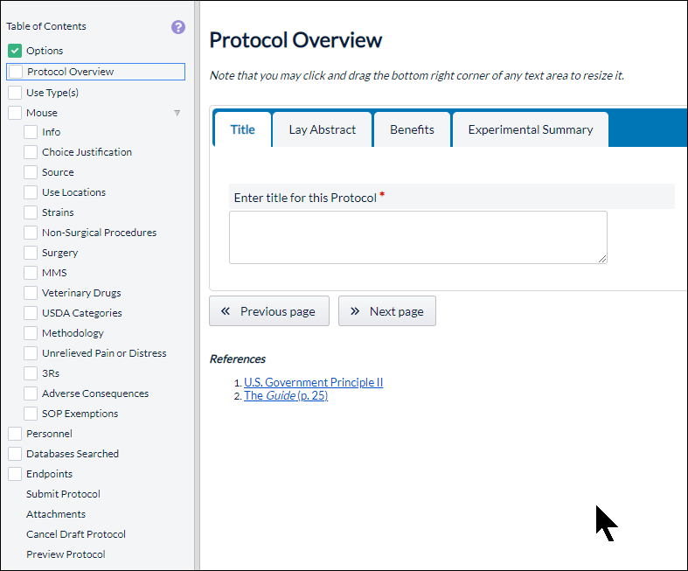

A green check in the box next to a section means that all required fields within the section have been filled out. All sections must have a check mark before you can submit the protocol.
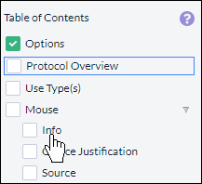

8. Different pages may have multiple tabs with required questions you will need to fill out before a section can be marked as complete.

9. Required questions have a red dotted border around them. These questions must be answered before you submit your protocol.
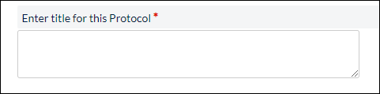
If all required questions are answered within a section, a green checkmark will appear next to the section within the table of contents.

10. Text fields are provided when you need to input a custom response.
If the text field has a toolbox, then you will be able to input rich text, such as bolded or italicized text, custom alignment, or bullet points.
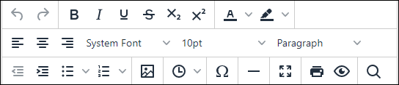

11. Radio button questions appear when only one choice is allowed from a set of configured choices.
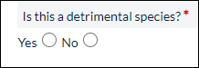

12. Check box questions appear when you can choose more than one choice from a set of configured choices.
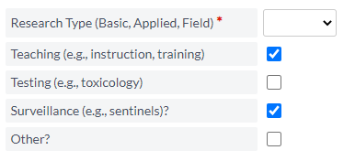

13. Questions with drop-down menus are similar to radio button questions and will let you select one answer from a set of configured choices.
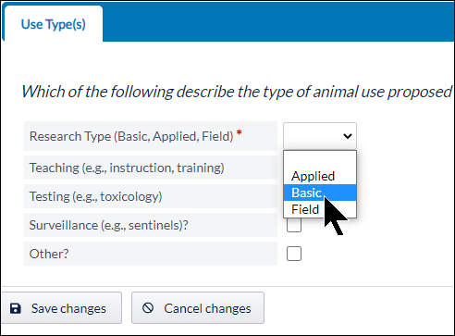

14. Add From List

The Add From List option allows you to choose from data that you have inputted previously. For example, if you are a PI, you may be able to add funding from your current list of funds, depending on your approved protocols.
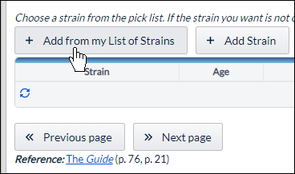

15. The Add New option allows you to add new data into the system, such as a new funding source, location, or strain.
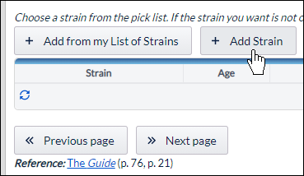

16. When adding from a list or adding new data, you can edit the data by clicking on the list item, and then clicking Edit. The list item will show up as red if it needs your attention.
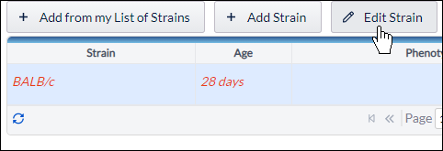

17. You can delete or remove an item from a list by clicking on the item, and then clicking Remove.

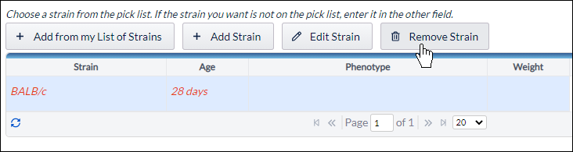

9. If a section is missing a green checkmark, it means that you still need to answer a required question. If you try submitting without answering all the required questions, you will see this message:
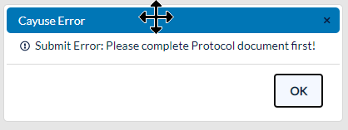

9. If you fill out everything correctly, you will return to the dashboard and your protocol will now be routed to the IACUC office for review and approval, and the protocol will appear in your Protocols in Review inbox.
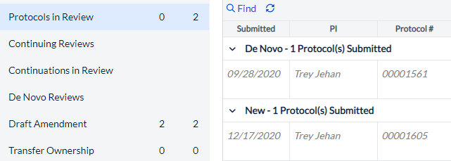
10. When your protocol has been reviewed and approved, it will appear in your Protocol Actions inbox.
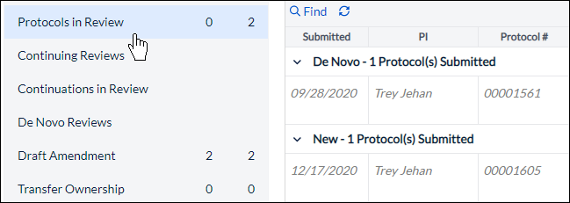

Best Practices for Completing the Protocol form
Understanding Dictionaries
The cayuse form uses dictionary lists to manage information from the following categories:
- Contacts
- Species/Strains
- Drugs/Hazardous Agents/Route of Administration
- Surgery/Procedure/Euthanasia/Restraint
- Facilities/Room
- Funding
TIP: If you are completing the form and don’t have the option of entering Other or New Drug
contact the IACUC office for help.
TIP: All personnel must register with cayuse by contacting the IACUC Office before they can be added to a protocol.
TIP: If you would like a person listed on your protocol to have access to your protocol, ask the IACUC Office to add them to your PI Group.

